Carbajosa, Maria Rubelle P.
BSIT 2B WMAD
Activity 1: Web architecture mapping/diagram
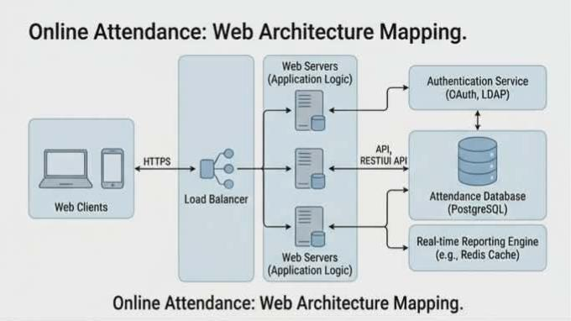

Site Mapping
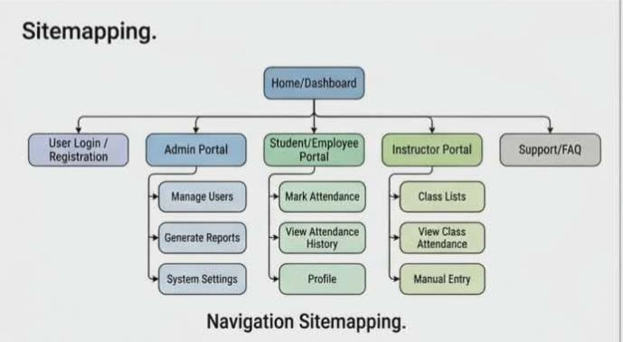

Website wireframe
